BUSINESS ANALYST PORTFOLIO

Case Study 01
Sales Performance & Profitability Analysis
A practical investigation into why strong sales were not consistently translating into strong profit.

Role | Tools | Dataset | Deliverable
Business Analyst | MySQL, Power BI | Superstore Sales | Analysis → recommendations → dashboard

The question I set out to answer
Why are sales relatively strong while profitability remains comparatively weak?
Short answer: The strongest signal was the relationship between higher discounting and weaker profitability, with Tables, product losses and regional discount exposure standing out as areas for management review.

Prepared by Rameshraj Selvaraju | Business Analyst | August 2026

1. Business problem and my approach
I treated this as a sales-to-profit investigation rather than starting with charts and looking for a story afterwards. I first defined the business questions, profiled the data, checked the quality issues, then used SQL to test the main hypotheses. From there I drilled into the strongest problem area and translated the findings into actions and a Power BI dashboard.
Step | What I did | Output
1 | Defined the sales-to-profit problem and business questions | Clear analysis scope
2 | Created the data dictionary and profiling checks | Common definitions + data-quality findings
3 | Tested hypotheses with SQL | Regional, category, discount and product findings
4 | Drilled across dimensions | Furniture → Tables → Discount → Region
5 | Converted findings into actions | Recommendations, owners and KPIs
6 | Built the Power BI views | Executive, deep-dive and product/loss pages

What I wanted the analysis to answer
- Which regions have a sales-to-profit gap?
- Which categories and sub-categories are hurting profitability?
- How does profitability change as discount increases?
- Which products are creating the largest losses?
- Which findings are strong enough to become management actions?

2. Data and quality checks
The project uses the Superstore Sales transactional dataset. The source contains 9,994 records. During loading and validation I found that the MySQL table contained 9,694 records, leaving a 300-record difference. I kept this limitation visible throughout the analysis instead of treating the SQL results as if they represented the full source.
Check | Result | Why it matters
Source vs MySQL | 9,994 vs 9,694 records | SQL results use the available database population
Critical NULLs | None identified | Key analytical fields were complete
Duplicate checks | Passed | Repeated Order ID + Product ID rows were investigated as legitimate transaction records
Dates | Stored as text in MySQL | Converted before chronological comparisons
Historical period | 2014–2018 | Supports year-over-year trend analysis

Data limitation to remember: the dataset does not contain inventory, returns, marketing campaign, customer satisfaction or detailed operational-cost data. Those factors therefore could not be tested as root causes.

3. What the analysis found
Area | Finding | Business meaning
Overall | $2.27M sales, $282.86K profit, 12.45% SQL margin | Baseline profitability is positive but leaves room to improve
Region | Central: 8.06% margin on ~$497.8K sales | High sales volume does not translate into equally strong margin
Category | Furniture: 2.32% margin on ~$733.0K sales | Furniture has the clearest category-level sales-to-profit gap
Discount | Margins become negative at 30% discount and above | Higher discount bands carry significant profitability risk
Tables | -$17.73K profit; -8.56% margin | Strongest sub-category problem area
Top 5 Tables losses | -$8.31K; -25.85% margin; 31.67% avg discount | A focused product review can target material losses

The most important finding: Tables
Tables generated about $206.97K in sales but lost about $17.73K, producing a -8.56% margin. The analysis also found that Tables represented about 78.6% of the identified negative profit among loss-making sub-categories. That made Tables the natural point for the next level of investigation.

Discount is the strongest suspected driver
Across the analysed discount bands, margin fell from 29.57% at zero discount to 16.61% at 10% and 5.15% at 15%. At 30% discount the margin was -10.05%, with further deterioration at higher discount levels.
Important interpretation: this is a strong association in the available transactional data, not proof that discounting alone causes the loss. Product mix, pricing and unavailable operational factors may also contribute.

4. Root-cause drill-down
Furniture → Tables → Discount → Region
Drill-down | Evidence
Furniture | Lowest category margin: 2.32%
Tables | 206.97K sales, -17.73K profit, -8.56% margin
Tables × Discount | Margin declined from 18.55% at 0% discount to -63.00% at 50% discount
Tables × Region | East: about -11.03K profit and -28.17% margin; West: highest Tables sales but only 1.75% margin

This drill-down is why I did not stop at 'Furniture is underperforming'. The more useful business story is that the Furniture problem is heavily concentrated in Tables, and within Tables the profitability deterioration becomes much more visible as discount exposure increases.

5. Recommendations
Priority | Recommendation | Owner / KPI
High | Review high-discount Tables transactions and establish appropriate approval controls. | Pricing / Commercial • Discount exposure, Tables margin
High | Review loss-making Tables products using absolute loss, sales, discount and margin together. | Product / Pricing • Product profit, loss count
High | Review regional discount practices, especially Central overall and East within Tables. | Regional Sales / Commercial • Regional margin + discount
Medium | Review Furniture/Tables pricing, costs, product mix and commercial justification. | Pricing / Product • Furniture & Tables margin
Ongoing | Use the dashboard to monitor sales, profit, margin, discount and loss-making products. | BI / Analytics • KPI trend monitoring

What management should do first
- Start with Tables transactions at 30%+ discount and identify where approval controls are needed.
- Prioritise the products with the largest absolute losses rather than looking only at percentage margin.
- Compare discount behaviour and profitability by region to understand why Central and East need different follow-up.
- Use the dashboard as an ongoing monitoring tool rather than a one-time reporting exercise.

6. Power BI dashboard
I built three views so a manager can move from the overall picture to the problem area and then to individual products.
Page | Purpose
Executive Overview | Sales, profit, margin, regional contribution and discount exposure
Profitability Deep Dive | Category, sub-category, discount and product profitability
Product & Loss Analysis | Bottom loss-making products and detailed product-level evidence

Executive Overview
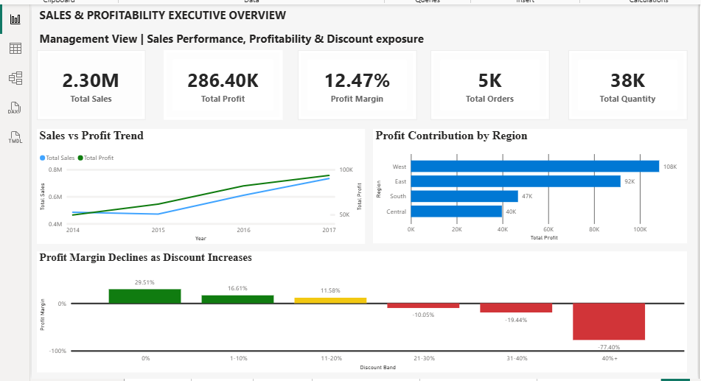

Profitability Deep Dive
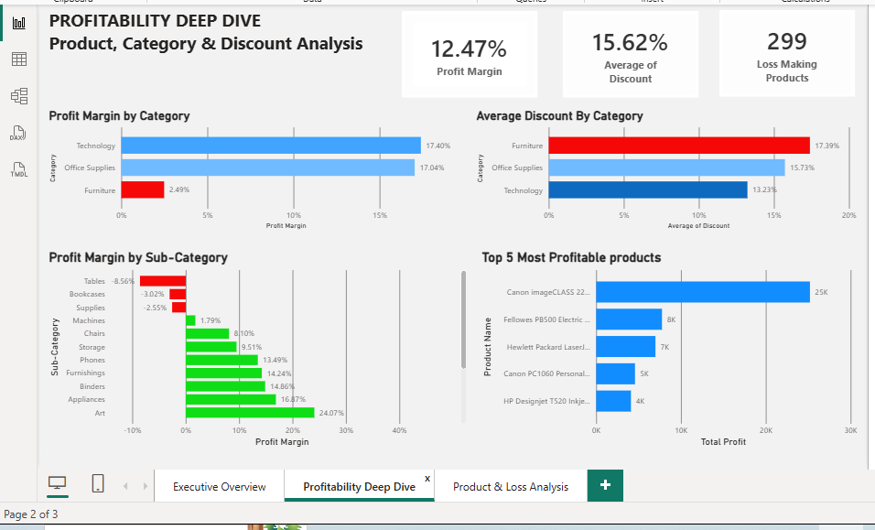

Product & Loss Analysis
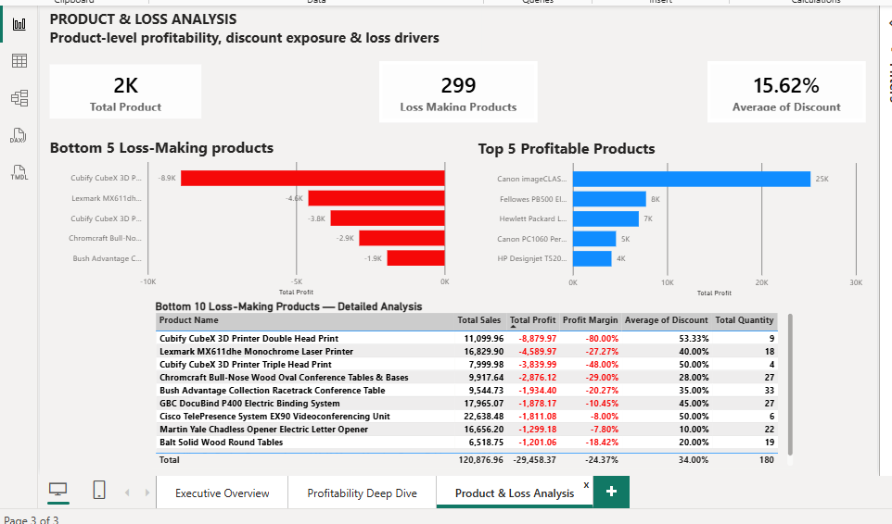

7. Stakeholders and communication
Stakeholder | What they need | Expected action
Business Management | Overall sales, profit, margin, key drivers | Approve priorities and strategic actions
Pricing / Commercial | Discount exposure and Tables profitability | Review thresholds and pricing strategy
Product Management | Loss-making products and margins | Identify products needing intervention
Regional Sales | Regional sales, margin and discount exposure | Investigate regional discount practices
BI / Analytics | KPI definitions, requirements and limitations | Maintain the monitoring dashboard

8. Limitations and what I would investigate next
The analysis identifies where the profitability problem appears and where management should investigate. It does not establish a complete causal model because several operational variables are missing.
- Reconcile the 300 missing database records before using the SQL population for production reporting.
- Bring in product cost, inventory, returns and promotion data to test whether discounting is still the strongest driver after controlling for those factors.
- Investigate why Central has the weakest overall regional margin and why East has the most severe Tables loss exposure.
- Track the recommended KPIs over time to see whether discount controls actually improve margin without damaging sales.

9. Evidence available in the project repository
The polished case study is the recruiter-facing summary. The supporting Sprint files show how the work was actually produced. I would keep both layers in GitHub: a clean README/case-study layer for a quick review, and an evidence layer for anyone who wants to inspect the working process.
Folder | What belongs there
01_Business_Problem | Problem statement, objectives, data dictionary
02_Data_Quality | Profiling report and validation evidence
03_SQL_Analysis | SQL business questions, queries/findings and screenshots
04_Recommendations | Recommendations, action plan and KPIs
05_Stakeholders | Stakeholder map and communication plan
06_PowerBI | PBIX file if shareable + three final dashboard screenshots
07_Portfolio | Polished PDF/DOCX case study

Do not upload secrets or unnecessary raw data. Keep database credentials, local connection files and anything containing private information out of the repository.

10. Final takeaway
The main lesson from this project is that high sales alone did not explain business performance. The useful BA question was where sales were failing to translate into profit. The analysis narrowed that gap to a specific pathway: Furniture → Tables → discount exposure, with regional differences adding another layer.
My recommendation is therefore not simply 'reduce discounts'. It is to review the high-risk Tables transactions, set sensible discount controls, investigate the products and regions behind the losses, and monitor the effect through the dashboard.
CASE STUDY 01 COMPLETE

